**Air University**

(Multan Campus)

|  |
| --- |
| Department of Computer Sciences |
| Software Engineering |
| **Junaid Saeed Roll#153172** |
|  |
| **BSCS-F-15-A-35**  **GIT & GITHUB ASSIGNMENT SOLUTION**  **Exercise 0:**  Create a Repository with the same name : |

Exercise 1:

Creating a Local Repository:

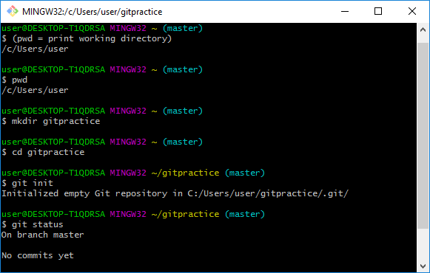

Changing editor and creating a new file:

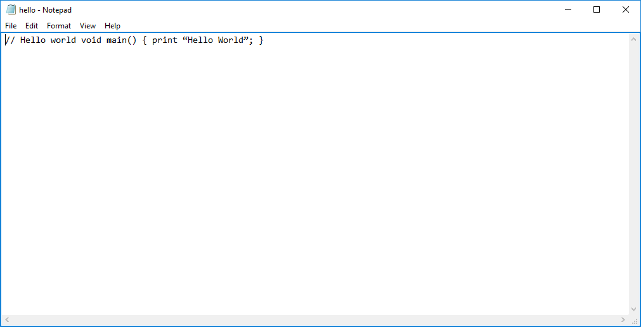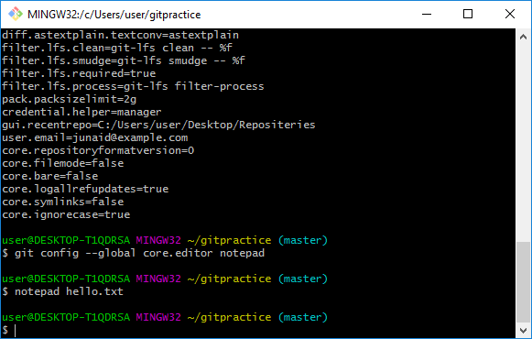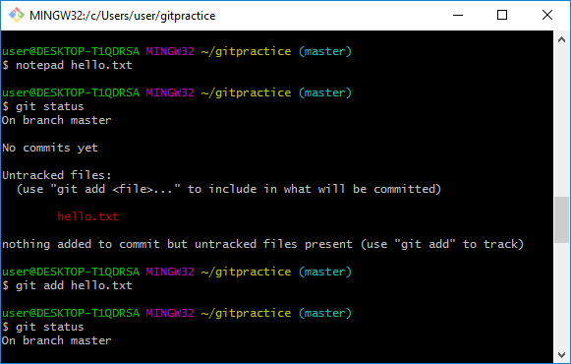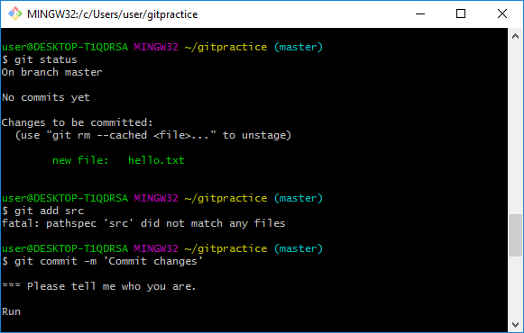

user@DESKTOP-T1QDRSA MINGW32 ~/gitpractice (master)

$ git commit

On branch master

nothing to commit, working tree clean

user@DESKTOP-T1QDRSA MINGW32 ~/gitpractice (master)

$ git log

commit b35f6769207110d4bc032c290f637132823a07cd (HEAD -> master)

Author: Your Name <you@example.com>

Date: Fri Sep 15 22:19:39 2017 -0700

description of change

user@DESKTOP-T1QDRSA MINGW32 ~/gitpractice (master)

$ git log -oneline

fatal: unrecognized argument: -oneline

user@DESKTOP-T1QDRSA MINGW32 ~/gitpractice (master)

$ git log --oneline

b35f676 (HEAD -> master) description of change

user@DESKTOP-T1QDRSA MINGW32 ~/gitpractice (master)

$ git log --n 3

error: Ambiguous option: n (could be --no-use-mailmap or --no-decorate)

usage: git log [<options>] [<revision-range>] [[--] <path>...]

or: git show [<options>] <object>...

-q, --quiet suppress diff output

--source show source

--use-mailmap Use mail map file

--decorate[=...] decorate options

-L <n,m:file> Process line range n,m in file, counting from 1

user@DESKTOP-T1QDRSA MINGW32 ~/gitpractice (master)

$ git log -n 3

commit b35f6769207110d4bc032c290f637132823a07cd (HEAD -> master)

Author: Your Name <you@example.com>

Date: Fri Sep 15 22:19:39 2017 -0700

description of change

user@DESKTOP-T1QDRSA MINGW32 ~/gitpractice (master)

$ git log -p

commit b35f6769207110d4bc032c290f637132823a07cd (HEAD -> master)

Author: Your Name <you@example.com>

Date: Fri Sep 15 22:19:39 2017 -0700

description of change

**diff --git a/hello.txt b/hello.txt**

**new file mode 100644**

**index 0000000..38f374e**

**--- /dev/null**

**+++ b/hello.txt**

@@ -0,0 +1,2 @@

+// Hello world void main() { print <93>Hello World<94>; }

+

\ No newline at end of file

user@DESKTOP-T1QDRSA MINGW32 ~/gitpractice (master)

$ git log -p -n 3

commit b35f6769207110d4bc032c290f637132823a07cd (HEAD -> master)

Author: Your Name <you@example.com>

Date: Fri Sep 15 22:19:39 2017 -0700

description of change

**diff --git a/hello.txt b/hello.txt**

**new file mode 100644**

**index 0000000..38f374e**

**--- /dev/null**

**+++ b/hello.txt**

@@ -0,0 +1,2 @@

+// Hello world void main() { print <93>Hello World<94>; }

+

\ No newline at end of file

user@DESKTOP-T1QDRSA MINGW32 ~/gitpractice (master)

$ git checkout <hash from log command or tag>

bash: syntax error near unexpected token `newline'

user@DESKTOP-T1QDRSA MINGW32 ~/gitpractice (master)

$ git checkout <hash from log command or tag>

bash: syntax error near unexpected token `newline'

user@DESKTOP-T1QDRSA MINGW32 ~/gitpractice (master)

$ git checkout master

Already on 'master'

user@DESKTOP-T1QDRSA MINGW32 ~/gitpractice (master)

$ git checkout HEAD filename

error: pathspec 'filename' did not match any file(s) known to git.

user@DESKTOP-T1QDRSA MINGW32 ~/gitpractice (master)

$ git checkout HEAD hello.txt

user@DESKTOP-T1QDRSA MINGW32 ~/gitpractice (master)

$ git add .gitignore

fatal: pathspec '.gitignore' did not match any files

user@DESKTOP-T1QDRSA MINGW32 ~/gitpractice (master)

$ git commit -m 'created.gitignore'

On branch master

nothing to commit, working tree clean

user@DESKTOP-T1QDRSA MINGW32 ~/gitpractice (master)

$ mkdir bin

user@DESKTOP-T1QDRSA MINGW32 ~/gitpractice (master)

$ touch bin/somefile.exe

user@DESKTOP-T1QDRSA MINGW32 ~/gitpractice (master)

$ touch file.class

user@DESKTOP-T1QDRSA MINGW32 ~/gitpractice (master)

$ git status

On branch master

Untracked files:

(use "git add <file>..." to include in what will be committed)

bin/

file.class

nothing added to commit but untracked files present (use "git add" to track)

user@DESKTOP-T1QDRSA MINGW32 ~/gitpractice (master)

$ git diff

user@DESKTOP-T1QDRSA MINGW32 ~/gitpractice (master)

$ git diff -staged

error: invalid option: -staged

user@DESKTOP-T1QDRSA MINGW32 ~/gitpractice (master)

$ $git rm <hello>

bash: syntax error near unexpected token `newline'

user@DESKTOP-T1QDRSA MINGW32 ~/gitpractice (master)

$ git rm --cached <filename>

bash: syntax error near unexpected token `newline'

user@DESKTOP-T1QDRSA MINGW32 ~/gitpractice (master)

$ mv oldfile newfile

mv: cannot stat 'oldfile': No such file or directory

user@DESKTOP-T1QDRSA MINGW32 ~/gitpractice (master)

$ git rm oldfile

fatal: pathspec 'oldfile' did not match any files

user@DESKTOP-T1QDRSA MINGW32 ~/gitpractice (master)

$ git add newfile

fatal: pathspec 'newfile' did not match any files

user@DESKTOP-T1QDRSA MINGW32 ~/gitpractice (master)

$ git mv oldfile newfile

fatal: bad source, source=oldfile, destination=newfile

user@DESKTOP-T1QDRSA MINGW32 ~/gitpractice (master)

Exercise 2:

Cloning an existing repository:

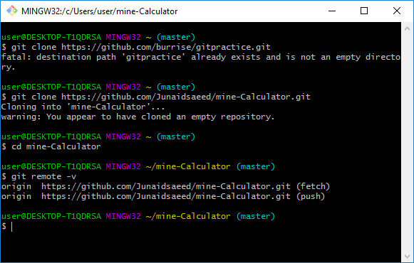

Exercise 3:

Contributing to an existing github project:

user@DESKTOP-T1QDRSA MINGW32 ~ (master)

$ https://github.com/Junaidsaeed/mine-Calculator.git

bash: https://github.com/Junaidsaeed/mine-Calculator.git: No such file or directory

user@DESKTOP-T1QDRSA MINGW32 ~ (master)

$ git clone https://github.com/Junaidsaeed/mine-Calculator.git

fatal: destination path 'mine-Calculator' already exists and is not an empty directory.

user@DESKTOP-T1QDRSA MINGW32 ~ (master)

$ cd mine-Calculator

user@DESKTOP-T1QDRSA MINGW32 ~/mine-Calculator (master)

$ git checkout -b JunaidsContribution

Switched to a new branch 'JunaidsContribution'

user@DESKTOP-T1QDRSA MINGW32 ~/mine-Calculator (JunaidsContribution)

$ git push origin JunaidsContribution

error: src refspec JunaidsContribution does not match any.

error: failed to push some refs to 'https://github.com/Junaidsaeed/mine-Calculator.git'

user@DESKTOP-T1QDRSA MINGW32 ~/mine-Calculator (JunaidsContribution)

$ git remote add upstream https://github.com/Junaidsaeed/mine-Calculator.git

user@DESKTOP-T1QDRSA MINGW32 ~/mine-Calculator (JunaidsContribution)

$ git pull upstream master

fatal: Couldn't find remote ref master

user@DESKTOP-T1QDRSA MINGW32 ~/mine-Calculator (JunaidsContribution)

$ git fetch upstream

user@DESKTOP-T1QDRSA MINGW32 ~/mine-Calculator (JunaidsContribution)

$ git merge upstream/master

merge: upstream/master - not something we can merge

user@DESKTOP-T1QDRSA MINGW32 ~/mine-Calculator (JunaidsContribution)

$ git status

On branch JunaidsContribution

No commits yet

nothing to commit (create/copy files and use "git add" to track)

user@DESKTOP-T1QDRSA MINGW32 ~/mine-Calculator (JunaidsContribution)

$ git add<filename>

bash: syntax error near unexpected token `newline'

user@DESKTOP-T1QDRSA MINGW32 ~/mine-Calculator (JunaidsContribution)

$ git add <mine-Calculator>

bash: syntax error near unexpected token `newline'

user@DESKTOP-T1QDRSA MINGW32 ~/mine-Calculator (JunaidsContribution)

$ git commit -m 'resolved conflicts'

On branch JunaidsContribution

Initial commit

nothing to commit

user@DESKTOP-T1QDRSA MINGW32 ~/mine-Calculator (JunaidsContribution)

$ git push origin JunaidsContribution

error: src refspec JunaidsContribution does not match any.

error: failed to push some refs to 'https://github.com/Junaidsaeed/mine-Calculator.git'

user@DESKTOP-T1QDRSA MINGW32 ~/mine-Calculator (JunaidsContribution)

Exercise 4:

Adding a Remote:

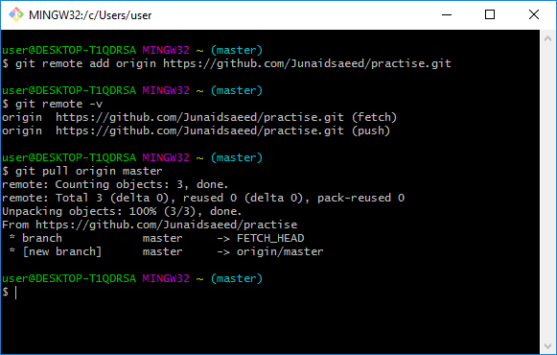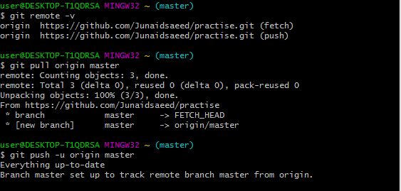

Exercise 5:

Branching and Merging:

user@DESKTOP-T1QDRSA MINGW32 ~ (master)

$ mkdir website

user@DESKTOP-T1QDRSA MINGW32 ~ (master)

$ cd website

user@DESKTOP-T1QDRSA MINGW32 ~/website (master)

$ git init

Initialized empty Git repository in C:/Users/user/website/.git/

user@DESKTOP-T1QDRSA MINGW32 ~/website (master)

$ notepad index.html

user@DESKTOP-T1QDRSA MINGW32 ~/website (master)

$ git add index.html

user@DESKTOP-T1QDRSA MINGW32 ~/website (master)

$ git commit -m 'initial checkin'

[master (root-commit) 600b47b] initial checkin

1 file changed, 0 insertions(+), 0 deletions(-)

create mode 100644 index.html

user@DESKTOP-T1QDRSA MINGW32 ~/website (master)

$ git branch

* master

user@DESKTOP-T1QDRSA MINGW32 ~/website (master)

$ git branch contactinfo

user@DESKTOP-T1QDRSA MINGW32 ~/website (master)

$ git branch

contactinfo

* master

user@DESKTOP-T1QDRSA MINGW32 ~/website (master)

$ git checkout contactinfo

Switched to branch 'contactinfo'

user@DESKTOP-T1QDRSA MINGW32 ~/website (contactinfo)

$ notepad index.html

user@DESKTOP-T1QDRSA MINGW32 ~/website (contactinfo)

$ git add index.html

user@DESKTOP-T1QDRSA MINGW32 ~/website (contactinfo)

$ git commit-m'add phone contact'

git: 'commit-madd phone contact' is not a git command. See 'git --help'.

user@DESKTOP-T1QDRSA MINGW32 ~/website (contactinfo)

$ git checkout master

Switched to branch 'master'

user@DESKTOP-T1QDRSA MINGW32 ~/website (master)

$ cat index.html

user@DESKTOP-T1QDRSA MINGW32 ~/website (master)

$ sit checkout contactinfo

bash: sit: command not found

user@DESKTOP-T1QDRSA MINGW32 ~/website (master)

$ notepad index.html

user@DESKTOP-T1QDRSA MINGW32 ~/website (master)

$ git add index.html

user@DESKTOP-T1QDRSA MINGW32 ~/website (master)

$ git commit -m 'add phone contact'

On branch master

nothing to commit, working tree clean

user@DESKTOP-T1QDRSA MINGW32 ~/website (master)

$ git checkout master

Already on 'master'

user@DESKTOP-T1QDRSA MINGW32 ~/website (master)

$ notepad index.html

user@DESKTOP-T1QDRSA MINGW32 ~/website (master)

$ git add index.html

user@DESKTOP-T1QDRSA MINGW32 ~/website (master)

$ git commit -m 'add title'

On branch master

nothing to commit, working tree clean

user@DESKTOP-T1QDRSA MINGW32 ~/website (master)

$ git branch

contactinfo

* master

user@DESKTOP-T1QDRSA MINGW32 ~/website (master)

$ git merge contactinfo

Already up-to-date.

user@DESKTOP-T1QDRSA MINGW32 ~/website (master)

$ cat index.html

user@DESKTOP-T1QDRSA MINGW32 ~/website (master)

$ git log --oneline --decorate --graph --all

* 600b47b (HEAD -> master, contactinfo) initial checkin

user@DESKTOP-T1QDRSA MINGW32 ~/website (master)

$ git branch -d contactinfo

Deleted branch contactinfo (was 600b47b).

user@DESKTOP-T1QDRSA MINGW32 ~/website (master)

Exercise 6:

Branching and remotes:

user@DESKTOP-T1QDRSA MINGW32 ~ (master)

$ git remote

origin

user@DESKTOP-T1QDRSA MINGW32 ~ (master)

$ git remote -v

origin https://github.com/Junaidsaeed/practise.git (fetch)

origin https://github.com/Junaidsaeed/practise.git (push)

user@DESKTOP-T1QDRSA MINGW32 ~ (master)

$ git remote add upstream https://github.com/Junaidsaeed/practise

user@DESKTOP-T1QDRSA MINGW32 ~ (master)

$ git branch -r

origin/master

user@DESKTOP-T1QDRSA MINGW32 ~ (master)

$ git checkout origin/feature123

error: pathspec 'origin/feature123' did not match any file(s) known to git.

user@DESKTOP-T1QDRSA MINGW32 ~ (master)

$ git branch-r

git: 'branch-r' is not a git command. See 'git --help'.

user@DESKTOP-T1QDRSA MINGW32 ~ (master)

$ git branch --r

origin/master

user@DESKTOP-T1QDRSA MINGW32 ~ (master)

$ is

bash: is: command not found

user@DESKTOP-T1QDRSA MINGW32 ~ (master)

$ Is

bash: Is: command not found

user@DESKTOP-T1QDRSA MINGW32 ~ (master)

$ git checkout origin/feature123

error: pathspec 'origin/feature123' did not match any file(s) known to git.

user@DESKTOP-T1QDRSA MINGW32 ~ (master)

$ Is

bash: Is: command not found

user@DESKTOP-T1QDRSA MINGW32 ~ (master)

$ git checkout master

Already on 'master'

Your branch is up-to-date with 'origin/master'.

user@DESKTOP-T1QDRSA MINGW32 ~ (master)

$ git clone https://github.com/Junaidsaeed/practise.git

Cloning into 'practise'...

remote: Counting objects: 3, done.

remote: Total 3 (delta 0), reused 0 (delta 0), pack-reused 0

Unpacking objects: 100% (3/3), done.

user@DESKTOP-T1QDRSA MINGW32 ~ (master)

$ cd practise

user@DESKTOP-T1QDRSA MINGW32 ~/practise (master)

$ git branch -r

origin/HEAD -> origin/master

origin/master

user@DESKTOP-T1QDRSA MINGW32 ~/practise (master)

$ cd

user@DESKTOP-T1QDRSA MINGW32 ~ (master)

$ git clone https://github.com/Junaidsaeed/practise.git practisecopy

Cloning into 'practisecopy'...

remote: Counting objects: 3, done.

remote: Total 3 (delta 0), reused 0 (delta 0), pack-reused 0

Unpacking objects: 100% (3/3), done.

user@DESKTOP-T1QDRSA MINGW32 ~ (master)

$ cd practise

user@DESKTOP-T1QDRSA MINGW32 ~/practise (master)

$ git checkout -b fix 123

fatal: '123' is not a commit and a branch 'fix' cannot be created from it

user@DESKTOP-T1QDRSA MINGW32 ~/practise (master)

$ git push

Everything up-to-date

user@DESKTOP-T1QDRSA MINGW32 ~/practise (master)

$ git push origin fix 123

error: src refspec fix does not match any.

error: src refspec 123 does not match any.

error: failed to push some refs to 'https://github.com/Junaidsaeed/practise.git'

user@DESKTOP-T1QDRSA MINGW32 ~/practise (master)

$ git push origin practisecopy

error: src refspec practisecopy does not match any.

error: failed to push some refs to 'https://github.com/Junaidsaeed/practise.git'

user@DESKTOP-T1QDRSA MINGW32 ~/practise (master)

$ cd /practisecopy

bash: cd: /practisecopy: No such file or directory

user@DESKTOP-T1QDRSA MINGW32 ~/practise (master)

$ git branch -r

origin/HEAD -> origin/master

origin/master

user@DESKTOP-T1QDRSA MINGW32 ~/practise (master)

$ git fetch origin

user@DESKTOP-T1QDRSA MINGW32 ~/practise (master)

$ git branch -r

origin/HEAD -> origin/master

origin/master

user@DESKTOP-T1QDRSA MINGW32 ~/practise (master)

$ git checkout -b fix123 origin/fix123

fatal: 'origin/fix123' is not a commit and a branch 'fix123' cannot be created from it

user@DESKTOP-T1QDRSA MINGW32 ~/practise (master)

$ notepad file.c

git add

$ git

user@DESKTOP-T1QDRSA MINGW32 ~/practise (master)

$ git add

Nothing specified, nothing added.

Maybe you wanted to say 'git add .'?

user@DESKTOP-T1QDRSA MINGW32 ~/practise (master)

$ git commit -m'second developer added a fourth line'

On branch master

Your branch is up-to-date with 'origin/master'.

Untracked files:

file.c

nothing added to commit but untracked files present

user@DESKTOP-T1QDRSA MINGW32 ~/practise (master)

$ git add

Nothing specified, nothing added.

Maybe you wanted to say 'git add .'?

user@DESKTOP-T1QDRSA MINGW32 ~/practise (master)

$ git commit -m'second developer added a fourth line'$git

On branch master

Your branch is up-to-date with 'origin/master'.

Untracked files:

file.c

nothing added to commit but untracked files present

user@DESKTOP-T1QDRSA MINGW32 ~/practise (master)

$ git push

Everything up-to-date

user@DESKTOP-T1QDRSA MINGW32 ~/practise (master)

$ cd /practisecopy

bash: cd: /practisecopy: No such file or directory

user@DESKTOP-T1QDRSA MINGW32 ~/practise (master)

$ git fetch

user@DESKTOP-T1QDRSA MINGW32 ~/practise (master)

$ git log --oneline

df23618 (HEAD -> master, origin/master, origin/HEAD) Initial commit

user@DESKTOP-T1QDRSA MINGW32 ~/practise (master)

$ git log -oneline

fatal: unrecognized argument: -oneline

user@DESKTOP-T1QDRSA MINGW32 ~/practise (master)

$ git remote show origin

* remote origin

Fetch URL: https://github.com/Junaidsaeed/practise.git

Push URL: https://github.com/Junaidsaeed/practise.git

HEAD branch: master

Remote branch:

master tracked

Local branch configured for 'git pull':

master merges with remote master

Local ref configured for 'git push':

master pushes to master (up to date)

user@DESKTOP-T1QDRSA MINGW32 ~/practise (master)